TROPHY EVENTS RULES

SPRING GIRL’S COMPETITIONS



**TY**L

The Tandridge League **7v7, 9v9 (U11) Girls Spring Trophy Event Competitions** are intended for teams in the Under 9/10, Under 11 age groups which would otherwise be playing Development or League Matches. The Trophy Events follow FA guidelines and offer players the opportunity to experience playing a fixed number of competitive matches over several match days.

Team managers and especially parents need to keep a sense of proportion over the significance of these games and not be influenced by the change from ‘development’ fixtures to competition matches.

**Rule 1:** All our **Trophy Event matches are for the fun and enjoyment** of the children who take part. They are NOT to boost the ego of the adults who run the teams and nor are they an excuse for over excitable parents to become too vocal or disruptive. **It is essential that team Officials manage the expectations and the behaviour of their ‘adult supporters’**. Just because these games involve an element of competition, it does not provide any excuse or justification for offensive and unsporting comments from the touchlines.

**The Competitions**

At each age group, the **competition will be known as Spring Trophy Cup Event**.

**Rule 2:** All matches shall be played in accordance with the FA Laws for 7v7 or 9v9 football as applicable to each Age Group. The following competition (Trophy Event) Rules will also apply, as too does League Rule 5 (Powers of Management) and League Rule 18.L (eligibility for a Semi Final or Final). The competitions will normally be played over five or six ‘match days’ depending on the number of teams in a competition. Between the first phase and second phase games, development fixtures will be played. Matters arising which are not covered by these rules will be determined by the Management Committee.

**First Phase – starting on the 9th of February 2025**

**Rule 5: Normal Time for the U10 and U11 age groups is 25 minutes each way.**

**Rule 6: Extra Time**

**Under 10’s & U11’s - Extra Time of 5 minutes each way will be played** if scores are level at the end of normal time. If still level after extra time, then a Penalty shoot-out must follow as described below.

**Rule 7: Penalty shoot-out**

A penalty shoot-out is compulsory for games which are drawn as per Rule 6 and is to be based on the **‘best of five’** penalties **taken alternately;** and if still even then ‘sudden death’. NB: The procedures for the Penalty Kicks shall be as described in Law 10 of the ‘The Laws of The Game’ as authorised by IFAB. **The winner of this shoot-out gains one ‘bonus’ point.**

**Rule 8.1:** **Results** must be notified to the League in the usual ways (**via the Matchday App**). Teams are required to clearly state the **Goals at the end of ‘normal time’** or **at the end of ‘extra time’** and **if a draw,** then **also show the Penalties scored by each team** in the separate Boxes on your Results Page.

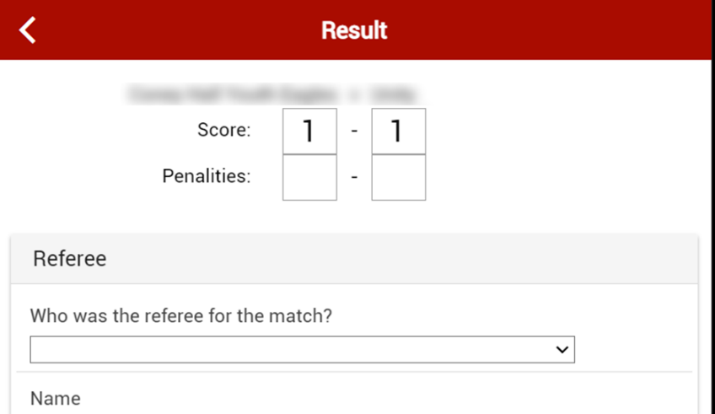

The results of these Trophy Event matches will be published on the League website.

**Rule 8.2:** **Rankings:** The League will collate the results and use them to determine ‘team rankings’ which will then form the basis for deciding the Fixtures in the second phase.

These rankings will be based on the allocation of ‘points’; with 3 points being allocated for a win and 1 point for a draw at the end of normal/extra time. **NB: a draw at the end of normal/extra time guarantees both teams one point irrespective of the penalties.** This rewards both teams for a well-earned ‘draw’ but also gives both teams the opportunity to gain one extra (bonus) point as confirmed in rule 7. **The bonus point is not added to the Table** unless and until it is needed as a tie breaker as explained here. **Where teams finish on equal points** their ranking will be determined by

1. Any bonus points - and if still equal by
2. Their ‘Head-to-Head’ result.
3. Average Goals Conceded. If three teams are equal on points (and a three-way Head-to-Head comparison does not work) the ranking will be decided by reference to the average number of goals conceded (AGC) (we use an average to reduce the effect of un-played games). However, if two of these three teams are still equal, then the Head-to-Head result between those two teams will determine the final ranking. The same principles apply to determine 'best' 2nd place etc. where that is necessary.
4. Toss of a coin.

The team which ‘wins’ the Penalty shoot-out will be allocated one **bonus point** (for the purposes of determining rankings for the second phase). For clarity a team finishing with 4 points gained through a win and a draw will finish above a team that gains 3 points for 3 draws plus 3 Bonus points for winning 3 penalty shoot outs.

**Rule 9**: In the event that a game does not take place where it is consequent upon the conduct of either team, then the League will have power to ‘award’ the game as a ‘win’ in the normal way.

**Rule 10**: This Trophy Event must be completed over a fixed number of match-days leaving little scope for rearrangements. In the event that a game does not take place owing to causes over which neither Club has control (for example bad weather leading to an unfit pitch) then both teams will be allocated one point. It is in everyone’s interest to get games played wherever possible and if in the final round of matches a weather postponed match is crucial to the final team rankings, the committee reserves the right to squeeze in a rearrangement, if the opportunity exists. Additionally, if bad weather causes the cancellation of a large percentage of games (typically 50% or more) on a particular match day, those games may be carried forward and played on a subsequent date.

**Rule 11**: **Progression to the Second Phase of the competitions.**

The Group stage of the competitions, as described above, constitutes the First Phase, at the end of which all teams will be ranked (as described above) in their own Group Table.

Based on their position in the Table, **ALL TEAMS** will go forward to the Second Phase of the Competition.

The Second Phase will usually involve playing against a team which was ranked in the same position in one of the other Groups in your Competition. The pairing for such games is determined by a pre-determined allocation. After that match, there follows a **final game** against a team which experienced the same outcome as your team in this second phase match.

**Rule 12**: This format is designed to give **EVERY TEAM** a continuing interest in their Trophy Event even if previous results have not gone in their favour. This could mean that teams participating in the second phase may not have won a single game, but the second phase will pair them with an opponent in roughly the same situation to hopefully enjoy and learn from the continuing experience of ‘competition’.

**Second Phase – starting on the 6th of April 2025**

**Allocation to the Second Phase Groups**

**Rule 13:** Applicable to those Competitions **consisting of 21 teams - with 4 Groups of 5 or 6**.

The **4 teams** which are determined by the League (**as described in Rule 8: Rankings**) to be **in** **first place** in their First Phase Group will go forward to the **Gold second phase** group where they will be paired (by a pre-determined allocation) with another team which also came ‘first’ in their initial group. These four teams then play a normal length Second Phase match or “semi-final” played in accordance with normal FA Rules for their age group.

Teams finishing **2nd** will go forward to the **Silver** second phase,

Teams finishing **3rd** will go forward to the **Bronze** second phase,

Teams finishing **4th** will go forward to the **Copper** second phase,

Teams finishing **5th** will go forward to the **Tin** Second phase,

Teams finishing **6th** will not go through to the second phase.

The allocation for the first Second Phase match will pair Group One v Group Four and Group Two v Group Three, **BUT** the Home team for each game will be determined individually by the League.

**Rule 14** In all competitions, the **winners of their Semi Final** ties will proceed to play in the **Final** of their competition on the last Match-day, whilst the losing semi-finalists will play a match for 3rd/4th place. In all games, **Penalty kicks** will **determine the winners** if scores are level (as described in Rule 6).

All the dates of the **Gold Finals** are to be advised, **GOLD** finals will be played at Greenacres Sports Club, 282 Limpsfield Road, Warlingham, Surrey, CR6 9RL, in May 2025.

The date for **ALL other** finals and play-offs will be played on **Sunday 11th of May 2025** and will be played at the home team’s ground.

**Rule 15** **WINNERS**

The winner of the **GOLD Final** will be declared to be **Autumn Trophy Cup Champions in the competition they are competing in.**

In the other Groups (Silver, Copper etc.) the winner will be declared to be **Group Winners**