TROPHY EVENTS
Phase One RULES for the
SPRING 5v5 competitions
TYL

The Tandridge League 5v5 Spring Trophy Event Competitions are intended for teams in the Under 7, and Under 8 age groups which would otherwise be playing Development Matches. The Trophy Events follow FA guidelines and offer players the opportunity to experience playing a fixed number of competitive matches over a number of match days.
Team managers and especially parents, need to keep a sense of proportion over the significance of these games and not be influenced by the change from ‘development’ fixtures to competition matches.
Rule 1: All our Trophy Event matches are for the fun and enjoyment of the children who take part. They are NOT to boost the ego of the adults who run the teams and nor are they an excuse for over excitable parents to become too vocal or disruptive. It is essential that team Officials manage the expectations and the behaviour of their ‘adult supporters’. Just because these games involve an element of competition, it does not provide any excuse or justification for offensive and unsporting comments from the touchlines.
Rule 2.1: Player Eligibility - IMPORTANT for Clubs with more than one u7 team or more than one u8 team.
All players are only allowed to participate for one team during the combined period of Phase One and Phase Two matches in their competition. Unlike for Development matches, players may not switch between teams for matches in the Spring Trophy Event. Once a player has taken part for one team, he/she will be ‘cup tied’ to that team and is not be eligible to play for a different team in the same club. All further appearances by that player can only be for the team for which they played their first Spring Competition match.
Rule 2.2: The Competitions: At each age group, the Spring Trophy Event will comprise a number of simultaneous competitions known variously as the Challenge CUP, SHIELD, TROPHY, PLATE. In larger age groups an additional competition known as the VASE may also be held. All teams will participate in one competition.
All matches shall be played in accordance with the FA Laws for 5v5 football as applicable to each Age Group. The following competition (Trophy Event) Rules will also apply, as too does League Rule 5 (Powers of Management) and League Rule 18.L (eligibility for a Semi Final or Final). The competitions will normally be played over five or six ‘match days’ depending on the number of teams in a competition. Between the first phase and second phase games, development fixtures will be played. Matters arising which are not covered by these rules will be determined by the Management Committee.
First Phase – starting in February 2024

Rule 3: Based upon the League’s perception of their relative strength, teams will be placed into the appropriate competition and drawn into one of the Groups for that competition. Such perception will be based on the (often considerable, but sometimes limited) data held regarding a team’s previous results.
Each Group will typically have four teams except where the overall number of participants requires a Group of a higher or lower number of teams.

Rule 4: Matches will be played under normal FA rules for the age group, BUT for ALL GAMES that finish as a DRAW after normal time, then the teams must proceed to a compulsory Penalty shoot-out.
Please Note – that when a game finishes with the scores level, the DRAW will earn both teams one point in their Group Table.

But then, both teams have the opportunity to earn one ‘Bonus Point’ by means of the Penalty shoot-out. To repeat: the compulsory use of Penalty Kicks is required only in order to determine the allocation of a “bonus” point where the scores are equal at the end of the match’.

Rule 5: Normal Time for the u7 and u8 age groups is 20 minutes each way.

Rule 6: Extra Time does not apply. For Under 7’s and Under 8’s - Extra Time will not be played. If scores are level at the end of normal time then a Penalty shoot-out must follow as described below.

Rule 7: Penalty shoot-out
A penalty shoot-out is compulsory for games which are drawn as per Rules 5 & 6 and is to be based on the ‘best of five’ penalties taken alternately; and if still even then ‘sudden death’. NB: The procedures for the Penalty Kicks shall be as described in Law 10 of the ‘The Laws of The Game’ as authorised by IFAB. The winner of this shoot-out gains one ‘bonus’ point.

Rule 8.1: Results must be notified to the League in the usual ways (via the Matchday App). Teams are required to clearly state the Goals at the end of ‘normal time’ and if a draw, then also show the Penalties scored by each team in the separate Boxes on your Results Page.
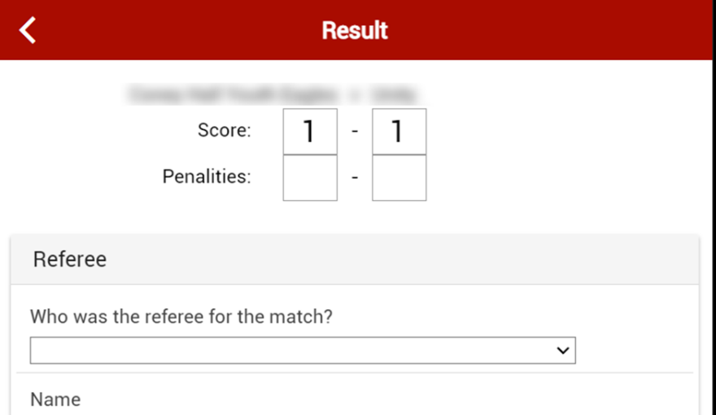

The results of these Trophy Event matches will be published on the League website.

Rule 8.2: Rankings: The League will collate the results and use them to determine ‘team rankings’ which will then form the basis for deciding the Fixtures in the second phase.
These rankings will be based on the allocation of ‘points’; with 3 points being allocated for a win and 1 point for a draw at the end of normal time. NB: a draw at the end of normal time guarantees both teams one point irrespective of the penalties. This rewards both teams for a well-earned ‘draw’ but also gives both teams the opportunity to gain one extra (bonus) point as confirmed in rule 7. The bonus point is not added to the Table unless and until it is needed as a tie breaker as explained here. Where teams finish on equal points their ranking will be determined by
- Any bonus points - and if still equal by
- Their ‘head to head’ result.
- Average Goals Conceded. If three teams are equal on points (and a three-way Head to Head comparison does not work) the ranking will be decided by reference to the average number of goals conceded (AGC) (we use an average to reduce the effect of un-played games). However if two of these three teams are still equal, then the Head to Head result between those two teams will determine the final ranking. The same principles apply to determine 'best' 2nd place etc. where that is necessary.
- Toss of a coin.

The team which ‘wins’ the Penalty shoot-out will be allocated one bonus point (for the purposes of determining rankings for the second phase). For clarity a team finishing with 4 points gained through a win and a draw will finish above a team that gains 3 points for 3 draws plus 3 Bonus points for winning 3 penalty shoot outs.

Rule 9: In the event that a game does not take place where it is consequent upon the conduct of either team, then the League will have power to ‘award’ the game as a ‘win’ in the normal way.

Rule 10: This Trophy Event must be completed over a fixed number of match-days leaving little scope for rearrangements. In the event that a game does not take place owing to causes over which neither Club has control (for example bad weather leading to an unfit pitch) then both teams will be allocated one point. It is in everyone’s interest to get games played wherever possible and if in the final round of matches a weather postponed match is crucial to the final team rankings, the committee reserve the right to squeeze in a rearrangement, if the opportunity exists. Additionally, if bad weather causes the cancellation of a large percentage of games (typically 50% or more) on a particular match-day, those games may be carried forward and played on a subsequent date.

Rule 11: Progression to the Second Phase of the competitions.
The Group stage of the competitions, as described above, constitute the First Phase, at the end of which all teams will be ranked (as described above) in their own Group Table.
Based on their position in the Table, ALL TEAMS will go forward to the Second Phase of the Competition.

The Second Phase will usually involve playing against a team which was ranked in the same position in one of the other Groups in your Competition. The pairing for such games determined by a pre-determined allocation. After that match, there then follows a final game against a team which experienced the same outcome as your team in this second phase match.

Rule 12:.This format is designed to give EVERY TEAM a continuing interest in their Trophy Event even if previous results have not gone in their favour. This could mean that teams participating in the second phase, may not have won a single game, but the second phase will pair them with an opponent in roughly the same situation to hopefully enjoy and learn from the continuing experience of ‘competition’.

FULL RULES FOR THE SECOND PHASE OF THE COMPETITIONS WILL FOLLOW.

