TANDRIDGE YOUTH FOOTBALL LEAGUE

MINUTES

LEAGUE COMMITTEE MEETING HELD ON MONDAY 13TH FEBRUARY 2023 AT THE HSBC SPORTS & SOCIAL CLUB LENNARD ROAD BECKENHAM KENT BR3 1QW COMMENCING AT 8:30pm

Meeting Commenced: 8:35pm

Apologies Received: Alan McIlvaney, AFC Croydon Athletic, Charlton Athletic RTC, Sanderstead Juniors, Southwark Allstars

Sue Dalziel: League Vice President: 27th Nov 1958 – 12th December 2022
Immediately before the meeting began, League Treasurer Steve Davis paid tribute to our League Vice President Sue Dalziel who very sadly died on 12th December 2022. Sue was born in Croydon in 1958 and lived in the area almost all of her life. With husband John, Sue helped run Thornton Rangers FC who had various teams in this league. In 2002 Sue joined the League Management Committee and spent the next 18 years working as a diligent, highly efficient and respected Registration Secretary. When she retired in 2020, Sue became an honorary Vice President of the League. After raising her family, Sue returned to full time work as a Teaching Assistant in two local schools. Steve concluded his brief tribute to Sue’s major contribution to this League, by quoting from the memorial website https://susandalziel.muchloved.com/

“Nurturing and helping children grow in knowledge, skills and confidence gave Sue a great deal of joy, whether it be her own children, grandchildren, the pupils she worked with or the boys and girls she was involved with through Youth Football.
Sue was an incredible caring person and touched many throughout her life, gone too soon from our side, she will be very much loved and missed”.

1.) Chairmans Report (John Plummer for Alan McIlvaney)

The Chairman Alan McIlvaney is unable to attend tonight but has asked for the following to be passed on to the members.

Alan would like to thank everyone involved in the League for their input in helping the League to move forwards with all the obstacles that we have all had to overcome from the delayed start of the season and the industrial action that has hampered the postal system and the recent weather that disrupted fixtures. Alan points out that some of the industrial action may still cause issues.

2.) (A) Treasurer’s Report: (Steve Davis)

a) Fines - since Christmas Rocky has been obliged to issue numerous clubs with a ‘so called’ Final Warning’ Invoice.
To recap, fines can involve a three-step procedure.
Step one – fine issued – if unpaid after 14 days, go to next step – Rule 6 I.
Step two - Doubled fine is issued – 14 days to pay – if still unpaid then go to next step
Step Three – 3rd Invoice (so called ‘Final Warning’) issued - Fixtures may be suspended after 7 days.
One way which many Clubs choose to avoid ever paying a doubled fine and to guarantee they never run the risk of having fixtures suspended is this: Pay a Fines Deposit in advance – Rocky will keep you informed of the rolling balance as and when a new fine is incurred and will suggest a ‘top up’ if your fines deposit is running low.
b) Bank Payments
When making payments by a bank transfer – Please always give a reference to let us know what it is being paid.
For Fines the best thing is to quote the Fine Number as shown on the invoice.
For Transfer Admin fees we want to see the clue from a reference such as TRF U12 etc.

c) Croydon Council Pitches
Reminder that Croydon Council stated back in September that they would only be making pitches available up to and including 16th April. They have previously extended for Purley Way only and previous attempts to get the date extended elsewhere have not been successful.
Those using Council pitches may need to consider where else they can play their last home games if they fall after the closure of their usual council ground.

e) Outstanding Invoices
There are a few Clubs with outstanding Invoices, and they will know who they are, so I will not seek to embarrass them here. If anyone wishes to pay an invoice at the meeting, we have the Card Reader here.

f) Bonds from New Clubs All Clubs which joined this season and are playing matches have paid their League Bond – and will be recorded in the AGM Accounts

g) Newly joined (or joining teams)
As you know, we welcome newly formed Mini Soccer teams at any time during the season.
Several newly formed teams will be taking part in the Spring Trophy Event Competitions and in fairness to all other teams, I will be asking these new teams for a modest entry fee as soon as I see that they are playing. I will be reviewing all these teams during this Half Term break.

(B) Fines Administrator Report: No Report (Rocky Horton)

3.) Secretary’s Report: (Derek Harris)

- Girls Football Update.

- The League introduce Girls Football after receiving requests from Clubs and encouraged by the London FA. Most teams in our and the Selkent League had to join Leagues in Kent and Surrey, so the teams had long journeys.

- The League has over 70 teams playing from U9 to U16.

- Now in its 3rd season the standard of the teams is improving but Girls divisions need more teams to provide the right standard of competition for all.

- There are 5 teams still competing in the County Cups at semi-final stages.

- The FA are ploughing cash into the Women’s and Girls game, and there are funds to develop new girl’s teams. We are meeting with the LFA to discuss how this can help Clubs to start new team.

- The County FAs are also offering free and reduced cost courses for female volunteers, recently the AFA held a Female Referee course at £50 normally £180.

- FA Trail on Heading the Ball appears to have been received very well in our U7’s and U8’s with no adverse comments. It is almost a certainty that this will become rule at U7 to U11 next season so all Clubs will need to address this through the closed season.

4.) Registrations Report

a) The registration and transfer window for teams from U12’s up to U17/18’s closes as from the 28th of February 2023 except for any exceptional circumstances

b) There are two registration systems but the only one that allows someone to play in this League is the Tandridge League system and a player is only registered to play once their details are on the FA system and they have been issued with a Tandridge Youth League Player Registration Card.

c) Feedback from League registration secretaries.

- Their workload is being unnecessarily increased because of the poor standard of the registrations being received, regularly details are left off the Registration cards and all too frequently they are receiving blank cards with photograph - photos not attached to the cards – no proof of birth – cards being signed by adults rather than the player – postal system being blamed for late receipt – numerous requests for last minute registrations.

- Player transfers: Before a player can be approached by any Club, they must first send a 7-day Notice of Approach (NOA) to the Club holding the players registration, stating their intention to approach the player. This also applies if the player approached a Club.
You can only approach a Club for one player at a time and must wait 28 days after approaching the first player, before approaching the same Club for a second player. Please also see the rules around multiple player transfers between specific teams.
The transfer should be processed between the Club Secretary and the relevant League Registration Secretary. There should be no further contact with the Club holding the player registration.

It is unlikely that this process can be achieved in a week.

5.) Fixtures Report

- Severe weather conditions have disrupted the fixtures programme, but we are just about back on track with the Cup/Shield/Trophy competitions, but there could be issues with Divisional games resulting in some decisions having to be made such as,

- Double Header fixtures being introduced.
- In division of 8 teams or less the 3rd fixture may prove to be difficult to introduce, your Fixtures Secretary will advise.

6.) Referee Secretary’s Report: (Casandra McKoy & Derek Harris)

- There has been a very small increase in referee numbers.

- The League in conjunction with Petts Wood FC ran a referee course on the 21st and 28th of January with 21 applicants whilst most are teenagers there were some adults that will add to the qualified referees in this League.

- A Surrey FA presentation dated the 3rd of December last, includes these statements relevant
to the issues and retention of Referees.

- We have seen statistics that show that 93.7% of football match officials had been physically or verbally abused during a match.
- Further statistics also highlighted that nine in ten referees said they had been verbally abused, with 59.7% experiencing some form of abuse every two games.
- For example, around 55% of officials in cricket and rugby said they experienced abuse while in charge of a match.
- Re-registration of referees was down 31% from last season.
- With a 24% loss of referees in 2021/22
(Note: if Surrey lost 24% in 21/22 and now 31% have not re-registered for this season; that equates to a loss over two years of 48% of those registered in 20/21).
- Approximately 8,000 matches being played without a referee per season.

7.) Match Card Secretary’s: (Debbie Heale)

We are still collating all the issues from the electronic match cards and dealing with the important issues. It is our intention to follow through on all issues eventually.
Please note that the match card is not the place to report un-played fixtures or complaints about the opposition or referees these complaints should be reported through the TAN 7 &TAN 8 forms.

8.) Disciplinary Report

At the September meeting it was suggested that we all try and improve on the incidents of dissent to the referee, but in some cases, this clearly fell on deaf ears. The FA and the County FAs are all extremely concerned with the increasing bad behavior from the sideline, involving both team officials and referees.

The London FA Disciplinary department has had to be strengthened as they are unable to cope with volume of reports and having to pend cases for months until they can be dealt with.

The Surrey FA have decided to do something about it and have set up a Joint County/Leagues group to address it by tackling the worst offenders, we are represented on this committee by Alan Donovan. See Surrey County Statistics showing the number of Investigations undertaken by them in a given period, The Surrey FA accounts for under 30% of our members but the data is most probably similar to all County FAs

 | 2019/20 | 2020/21 | 2021/22
Investigations | 410 | 357 | 611
(Youth / Adults) | (209/201) | (147/210) | (272/339)
Abandoned Games | 37 | 59 | 62
Referee Assault | 3 | 5 | 2
Referee Physical Assault | 3 | 9 | 4
Referee Threats | 13 | 1 | 36
Charges Success | 89.23% | 92.94% | 91.56%
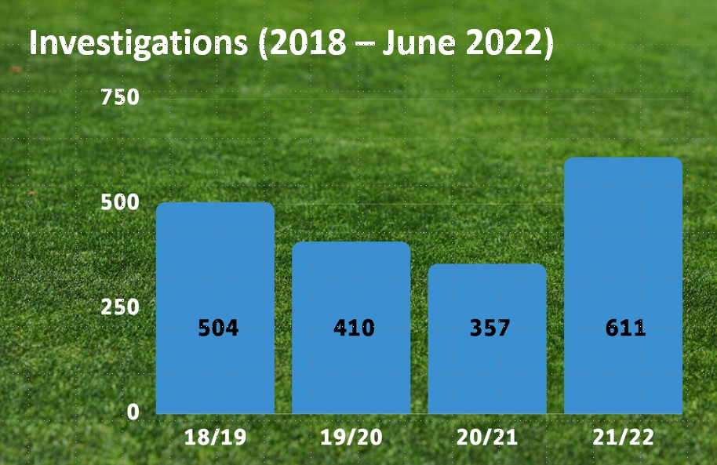

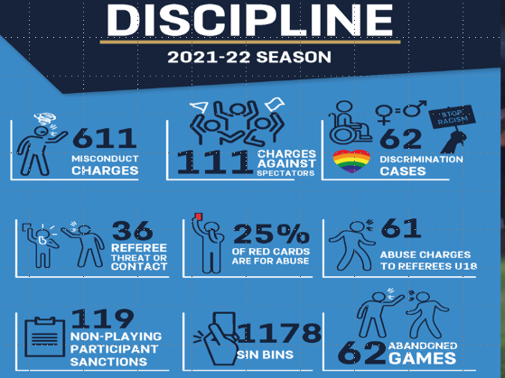
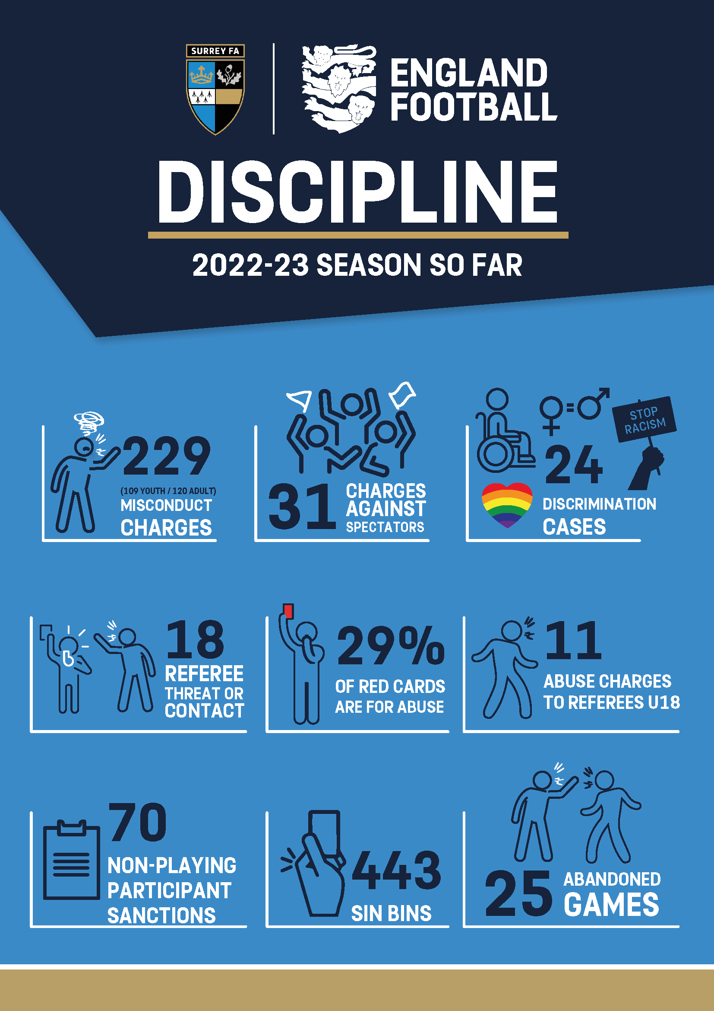

9.) Welfare Report

Most County FAs are promoting courses around Safeguarding though their Newsletters the
Surrey FA appear to be prominent in promoting Safeguarding courses at their Dorking HQ, typically the sessions cost £5, there are also sessions around Surrey.

10.) Cups and Competitions John Dalziel & Paul Carter

- Autumn Trophy Competitions Gold Finals now published for the 5th and 12th of March to held at the John Fisher Sports Ground.
- Update on all Competition’s U12 upwards.
- Spring Trophy Competition now being finalised to start on Sunday 26th of February.

11.) Trophies

- A repeating notice has been put on the website reminding all of the deadline for the Spring Trophy Returns (28th February) and suggesting tonight as a receiving point, after which appointments for their return will have to be agreed with;
Sue Cairney (Oxted) 01883 716121 suecairney42@gmail.com
Derek Harris (Coulsdon) 020 8668 3535 drharris@sky.com
John Dalziel (Croydon) 020 8684 9011 john_dalziel__72@hotmail.com
Alan McIlvaney (Orpington) 01689 838094 amacorpington22@ntlworld.com
Val Busby (West Wickham) 020 8325 0184 valerianbusby@gmail.com

- All Clubs holding trophies have received an email detailing which trophies they have.
- Sue advised that 59% of the trophies required have now been received, this leave a further 41% to be returned. It would be very much appreciated that these trophies are returned promptly and before the 28th February as there is a considerable amount of time needed to prepare the trophies for re-issue.

12.) Website

- Clubs can now view a list of their player Registrations. The list for each of a Club’s teams can be viewed by League Fixtures Secretaries and Club Secretaries, through the Club’s team option on the website.

13.) Roll Call:

The following Clubs were not in attendance and will be fined in accordance with Rule 5 (G).
Academix FC– Alfold FC – Balham Youth FC – Blue Stars Elite FC – Brixistane FC – Broomwood FC – Champs FC – Cray wanderers Youth FC – Croydon FC Youth – Dalmain Athletic GFC – Deptford Lionesses FC – Elite JR FC – Farnborough Old Boys Guild FC – Holmesdale Youth FC – London Kickers – Mini Sports Stars FC – Moonshot FC – NexGen FC – Northcote Elite FC – Oakwood Youth FC – Peckham Town - Penge Panthers FC – Raynes Park Vale FC – Rise United FC - Selsdon Juniors – Sevenoaks Town JFC - Southbridge United FC – Sports Attack FC – Streatham FC – Sundridge Allstars FC – Ten Em Bee – The Little Giants FC – Tooting Park Rangers FC – Unity FC – Universal FC – Vision FC – Wandsworth Lions FC – Warlingham Colts - Welling United FC.

14.) Any Other Business:

There was no AOB.

15.) Dates of Next Meetings:

Monday 8th May 2023

Meeting Closed: 9:24pm

