Tandridge App

Welcome to the Tandridge App!
The App is only for named, compliant, managers, assistant managers and team administrators of Tandridge teams.
Brief instructions are available for the following sections:
- Setup
- Demo Mode
- General Usage
- Matchcard - General
- Matchcard - Entering Players
- Matchcard - Entering Result/Sending
- Settings

Tandridge App - Setup
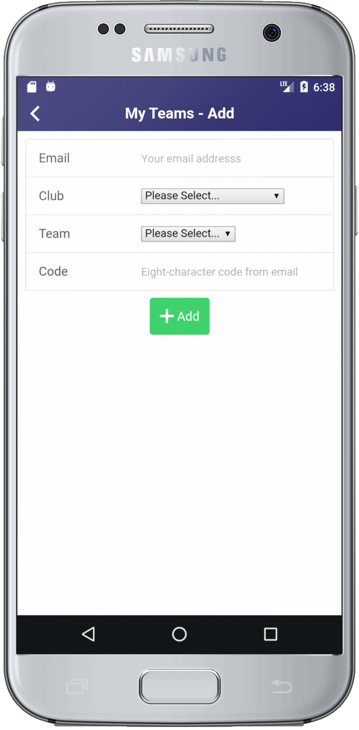

Setup
- Go to your phone's App Store
- Find and install the Tandridge App
- Ask your club secretary or fixture secretary to email you with your registration code
- Run the App and from the "My Teams" page, click the white 'plus' at the top
- Enter your email address, select your club, enter your registration code you got via email and select your team
- Click the green "Add" button
- If you are the manager, assistant manager or team administrator of additional teams, you will need a code for each team to register it on the App
The registration code is unique to you and the team. Do not share the code with anyone else.

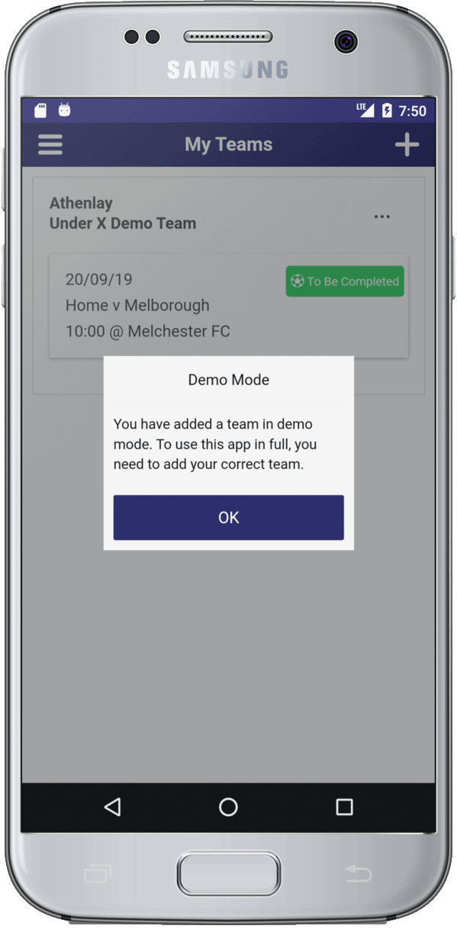
Tandridge App - Demo Mode

Demo Mode
To allow you to have a play with the App before the season starts, you can add a team in “demo mode”. To do this, run the App and from the “My Teams” page, click the white ‘plus’ at the top. Enter anything for the email address (this will be completely ignored) and pick any club and team (again, these are ignored). For the registration code enter “demodemo”.
This will now give you a fictious team to have a play with. A series of prompts will show as you move through the app (these won’t appear when you use the App for real) and you can go through the whole process including submitting the matchcard for the fake fixture.

Tandridge App - General Usage
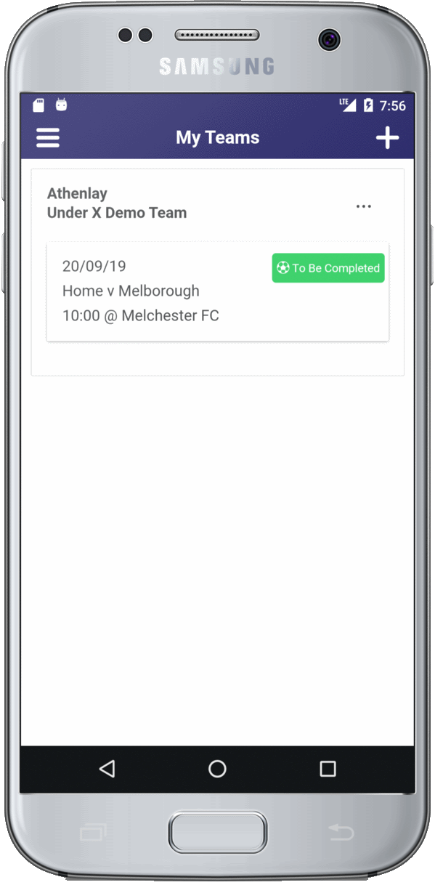

General
The App will show your fixtures on the day before the game. Once the App shows your fixture for the next day you are good to go. The details needed to complete the matchcard have been downloaded to your phone and you do not need to be online at the match itself.
The initial part of the matchcard procedure – checking the opposition players registration cards – must be carried out as per rule immediately before the kick-off by running the App and entering the registration numbers and shirt numbers of the opposition players.
After the match, you then complete the matchcard on the App by entering the score and a few other pieces of information. The matchcard must then be submitted to the League by 6pm on the day of the match. If you have a data signal at the match, you can send it in straight-away. If it fails to be sent – if you have no signal – you can return to the App once you get home and it will send the matchcard in. Make sure it has been sent by 6pm!

Tandridge App - Matchcard - General
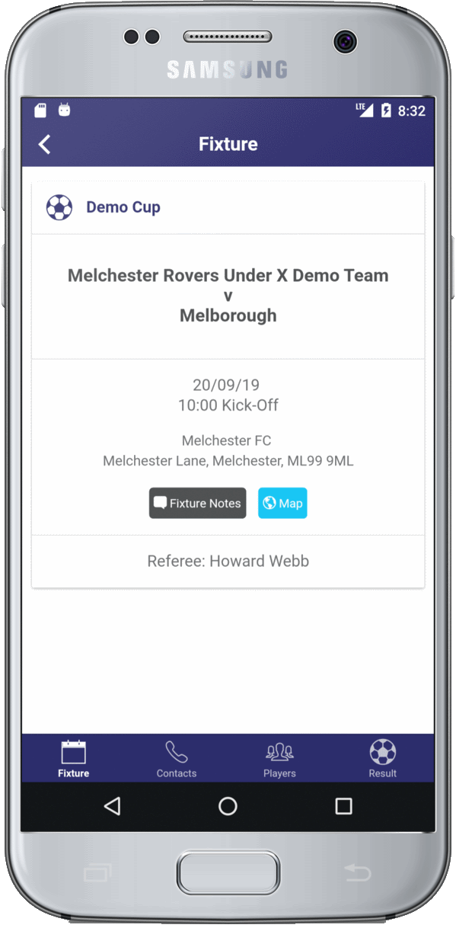

Matchcard - General
On the day before the match, the App will show summary details of the fixture on the “My Teams” page. Tap a fixture to enter the matchcard for that fixture.
A row of tabs at the bottom take you through the various sections. The first tab – “Fixture” – shows the details of the game. Tap the black “Fixture Notes” button to see any notes entered by the home team for the fixture. Tap the “Map” button to see where the ground is.
The next tab – “Contacts” – shows you the name, email and phone number of the managers, assistant managers and fixture secretaries for the teams, along with the details of any league-appointed referee.

Tandridge App - Matchcard - Entering Players
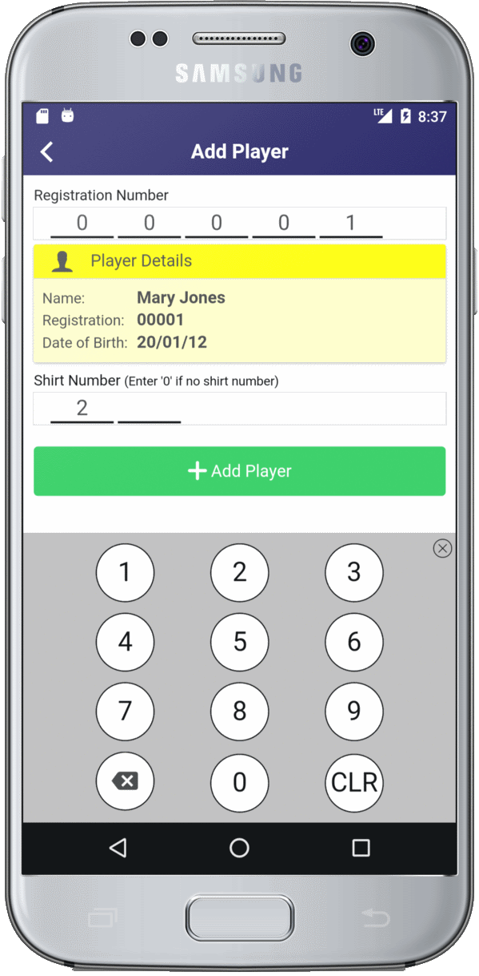

Matchcard – Entering Players
The “Players” tab is where you enter the details of each opposition player. As per League rules, this needs to be done immediately before kick-off.
Tap the big green “Add Player” button to get started. You need to check each player against their registration card and then enter their registration number into the App. The App will only recognise valid registration numbers for the opposition team.
Assuming the number is valid, the player’s name and date of birth are displayed and you should double-check this against the registration card. Then enter their shirt number and tap the green “Add Player” button at the bottom. The page resets for you to enter the next player.
When done, tap the left-arrow at the top of the page to go back to the “Players” tab. This will now be showing all the players you have entered along with a count of the number you have done. Check this is right. You can add further players or remove players if necessary.
If the App does not recognise the registration number of an opposition player as being valid for the opposition, it will tell you. You can manually add the details for this player, but double-check the registration card and discuss with the opposition manager. It should be extremely rare for a registration card to be valid if the App does not know about it!
You are now ready to play the game!

Tandridge App - Matchcard - Entering Result/Sending
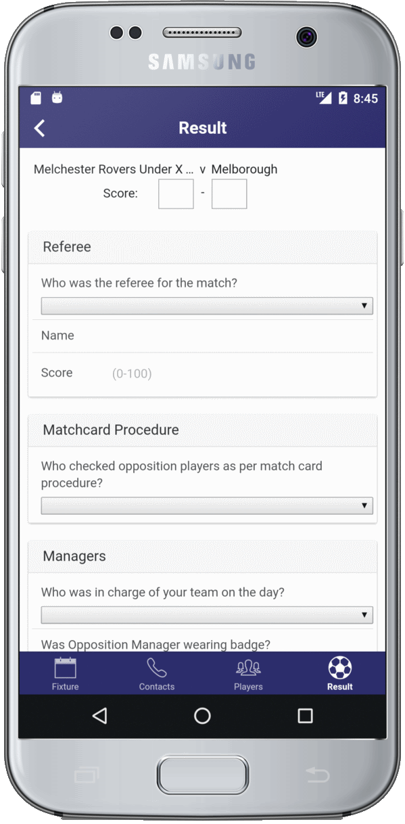
Matchcard – Entering Result / Sending

After the game, return to the App and go to the “Result” tab for the fixture. You need to enter:
- The score
- Select the referee – this will show the league appointed referee (if there was one) and all the manager and assistant managers from the two teams. If one of those was the referee, select them, otherwise select “Other – Specify” and fill in the two fields for the referee’s forename and surname. If you have someone else who regularly referees for you can enter their name on the “Settings” page to let you select them next time rather than having to type in their name.
- Enter your mark for the referee (between 1 and 100)
- Select who checked the opposition players’ matchcards and enter them in the App. Select the relevant person if shown, or pick the “Other – Specify” option and enter the person’s name. As for the referee, if you have someone who regularly checks the opposition registrations, you can enter their name in “Settings” so you don’t have to keep typing their name. (See Settings below).
- Select who was in charge of the team on the day. Again, this will list the manager and assistant, or you can pick “Other – Specify” and enter the name of the person who was the manager on the day.
- Select your "Sportmanship" marks for each of the opposition officials, players and supporters (between 1 and 10).
- Change the time that the game kicked off if necessary.
- Enter when the game concluded

You also need to:
- Tick to confirm whether or not the match was played in full
- Tick to confirm that you have followed matchcard procedure for each of the opposition players
- Enter any comments you wish

When done, click the “Send Matchcard” button at the bottom.
If you have a data connection at the game, the matchcard should go straight away. Otherwise it will tell you that it failed to be sent. If it failed, run the App a bit later when you have a signal and it should then go.
Once the matchcard has been sent, the fixture will disappear from the App.
Make sure you submit the result by 6pm!
If the matchcard has been sent, then your Club fixture secretary will not need to enter the score into the website themselves.
If for any reason you are unable to send the card by 6pm, let your Club fixture secretary know so they can enter the score by the 6pm deadline. You should still submit the matchcard as soon as you are able.

Tandridge App - Settings

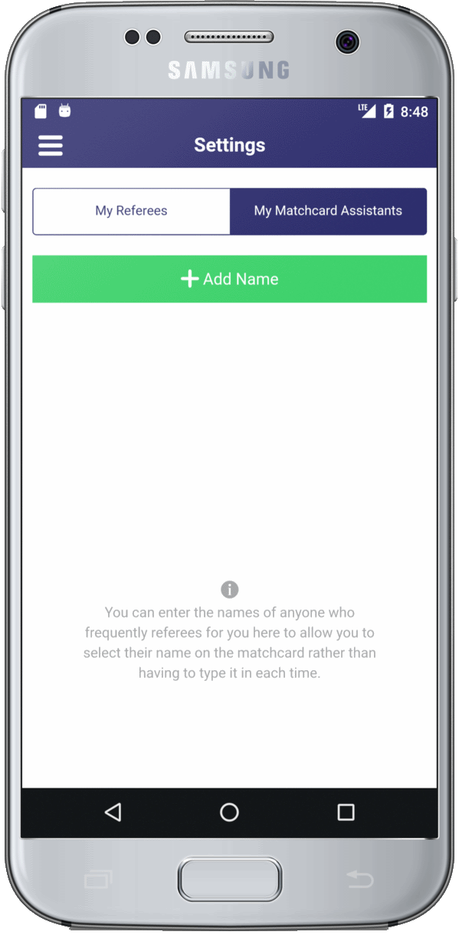

Settings
The “Settings” page lets you enter the name of anyone who either regularly referees for you, or who regularly helps with checking the opposition players registrations. Once entered on this page, their name will appear in the list on the matchcard “Results” tab and you can simply select their name rather than having to type it in each time.

