Setting Up an Account

Overview
Logon accounts to the Tandridge League website are only necessary for certain League Officials, Club Secretaries and Club Fixture Secretaries.
To be able to create an account, you must have been sent an email from the website by either a League Official or your Club Secretary.
Once you have an account set up, you will be able to perform certain actions, such as amend details for your club or enter fixture details and results.

Steps
You should have received an email with a subject line of “Tandridge Account Confirmation Required”.
Click the link at the bottom of that email. This takes you to the Tandridge League website.
Enter your email address (this must be the address where you received the email), enter a password of your choosing (must be eight or more characters) and then enter it again for confirmation. Then click the “Continue” button.
You will now see the following screen. Re-enter your email address, the password you chose and click the “Sign In” button.
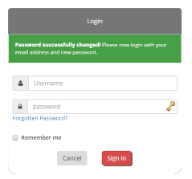 You should now be logged in.

1

Troubleshooting
Not received the email? | • | Check your spam/junk folders. The email will have been sent from an address of web@selkent.org.uk
 | • | Ask your club secretary to send the email again.
Message “Invalid or expired code”? | • | Have you received more than one confirmation email? Only the code in the most recent email will be valid.
 | • | Ask your club secretary to send a new email and click the link in that one.
Message “Email address does not match the supplied code”? | • | You must enter the exact same email address that the email was sent to. The address is included in the body of the email you received.

